Chapter 13, Solution 56.

Find the power absorbed by the 10-Ω resistor in the ideal transformer circuit of Fig. 13.120.

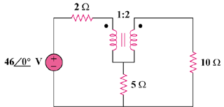

Figure 13.121
For Prob. 13.56.

Solution

We apply mesh analysis to the circuit as shown below.

1 : 2

46V

+
−

I₁

I₂

+

v₂

−

10 Ω

5 Ω

2 Ω

+

v₁

−

For mesh 1, 46 = 7I₁ – 5I₂ + v₁ (1)

For mesh 2, v₂ = 15I₂ – 5I₁ (2)

At the terminals of the transformer,

v₂ = nv₁ = 2v₁ (3)

I₁ = nI₂ = 2I₂ (4)

Substituting (3) and (4) into (1) and (2),

46 = 9I₂ + v₁ (5)

v₁ = 2.5I₂ (6)

Combining (5) and (6), 46 = 11.5I₂ or I₂ = 4

P₁₀ = 0.5|I₂|²(10) = 80 watts.

